import pandas as pd

import numpy as np

import matplotlib.pyplot as plt

import seaborn as sns

**###### Load data set**

dataset = pd.read_excel("D:\\ML\\dataset\\Bank_Personal_Loan_Modelling.xlsx",sheet_name=1)

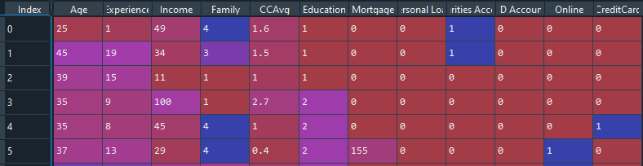

**#### Check null value in dataset**

dataset_null = dataset.isnull().sum()

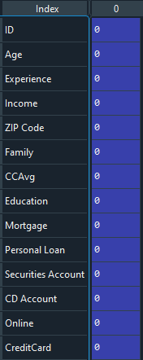

**#### Drop Unwanted Features**

dataset = dataset.drop(["ID","ZIP Code"],axis=1)

**##### To Model Creation**

from sklearn import tree

tree_model = tree.DecisionTreeClassifier(max_depth=22)

predictors = pd.DataFrame([dataset['Age'],dataset['Experience'],dataset['Income'],dataset['Family'],dataset['CCAvg'],dataset['Education'],dataset['Mortgage'],dataset['Securities Account'],dataset['CD Account'],dataset['Online'],dataset['CreditCard']]).T

tree_model.fit(X = predictors,y=dataset['Personal Loan'])

with open ("Dbank.dot",'w') as f:

f = tree.export_graphviz(tree_model,feature_names=['Age','Experience','Income','Family','CCAvg','Education','Mortgage','Securities Account','CD Account','Online','CreditCard'],out_file=f)

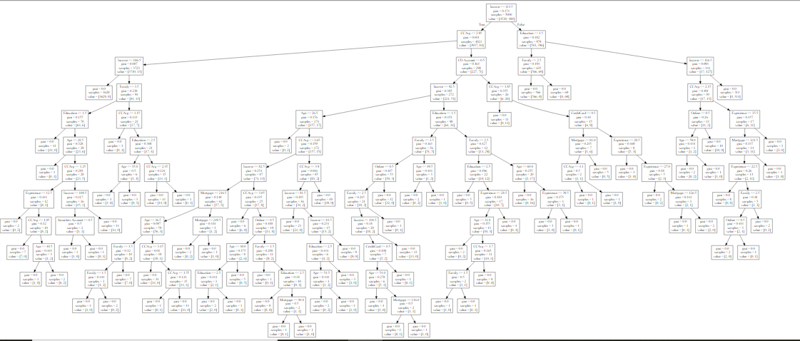

**###### Model Accuracy**

tree_model.score(X = predictors,y = dataset['Personal Loan'])

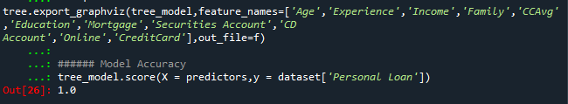

**###### Random Forest Classifier**

from sklearn.ensemble import RandomForestClassifier

rf_model = RandomForestClassifier(n_estimators=1000,max_features=2,oob_score=2)

features = ['Age','Experience','Income','Family','CCAvg','Education','Mortgage','Securities Account','CD Account','Online','CreditCard']

rf_model.fit(X = dataset[features],y=dataset['Personal Loan'])

print("OOB_Score:",rf_model.oob_score_)

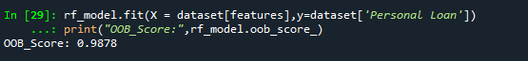

**#####To Find the Important variable**

for features,imp in zip (features,rf_model.feature_importances_):

print(features,imp)

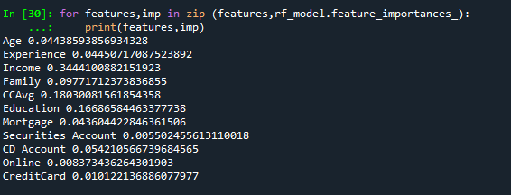

**###### To important variable are ”Income”,”CCAvg”,”Education”.**

**###### To make Decision tree for independent variable = ”Income”,”CCAvg”,”Education”, Dependent Variable = “Personal Loan”.**

**### Bulid the Tree Model**

tree_model = tree.DecisionTreeClassifier()

predictors = pd.DataFrame([dataset['Income'],dataset['CCAvg'],dataset['Education']]).T

tree_model = tree.DecisionTreeClassifier(max_depth=6)

tree_model.fit(X = predictors, y = dataset['Personal Loan'])

with open ("Dbank1.dot",'w') as f:

f = tree.export_graphviz(tree_model,feature_names=['Income','CCAvg','Education'],out_file=f)

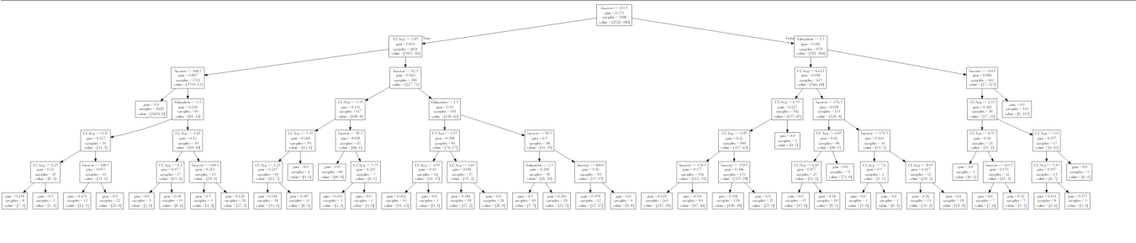

**##### Model Accuracy score:**

tree_model.score(X=predictors, y=dataset['Personal Loan'])

